GC Expressing
Project information
Group 8:4

SHAME THAT SH!T

SDG: Decent Work and Economic Growth (8) & Responsible Consumption and Production (12)

Description: We found that there is a high degree of lack of transparency in the high-end fashion value chains. Because of this, customer’s lack of knowledge can be freely exploited and misled through high prices. We want to change this by exposing malpractices and promoting responsibility/ sustainability. This will be done through by connecting with customers directly through social media platforms. We have created provocative content that is spread on the platforms and intended to become viral. By doing so, we hope to impact customer’s behavior in the market and drive change through a simple supply and demand notion. Indirectly, we hope to see more pronounced CSR policies and disclosure of supplier information from the high-end fashion brands.

Names: Victor Wolf, Oscar Hegelund, Pontus Lagerberg, Ellen Gunnarsson, Joel Werner, Edwin Ashnai

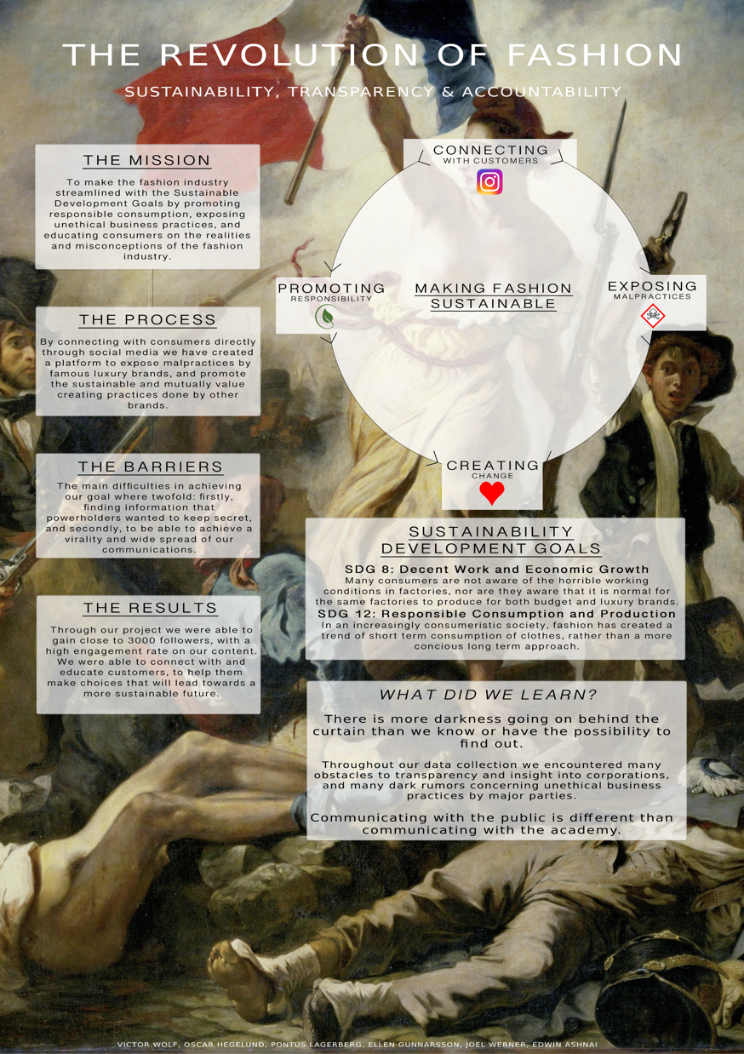
Instagram: @shamethatshit

